Command Line
Contents
The types of command line interfaces 1
Git Bash 1
Powershell 2
Unix Commands 2

The types of command line interfaces

Git Bash
- Simple
- Unix commands
- Downloaded from webpage
- Can use git specific commands
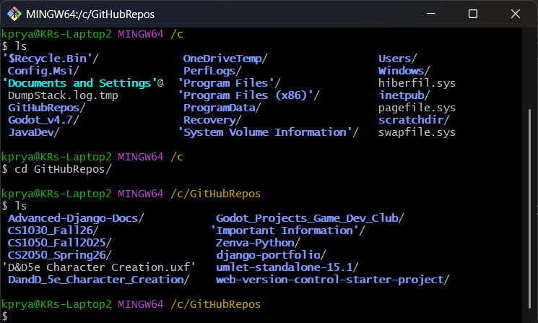

Powershell
- Complex
- Uses Unix, Linux, and Object-Oriented commands
- Integrated with Windows, otherwise must be downloaded to device
- Can use git specific commands
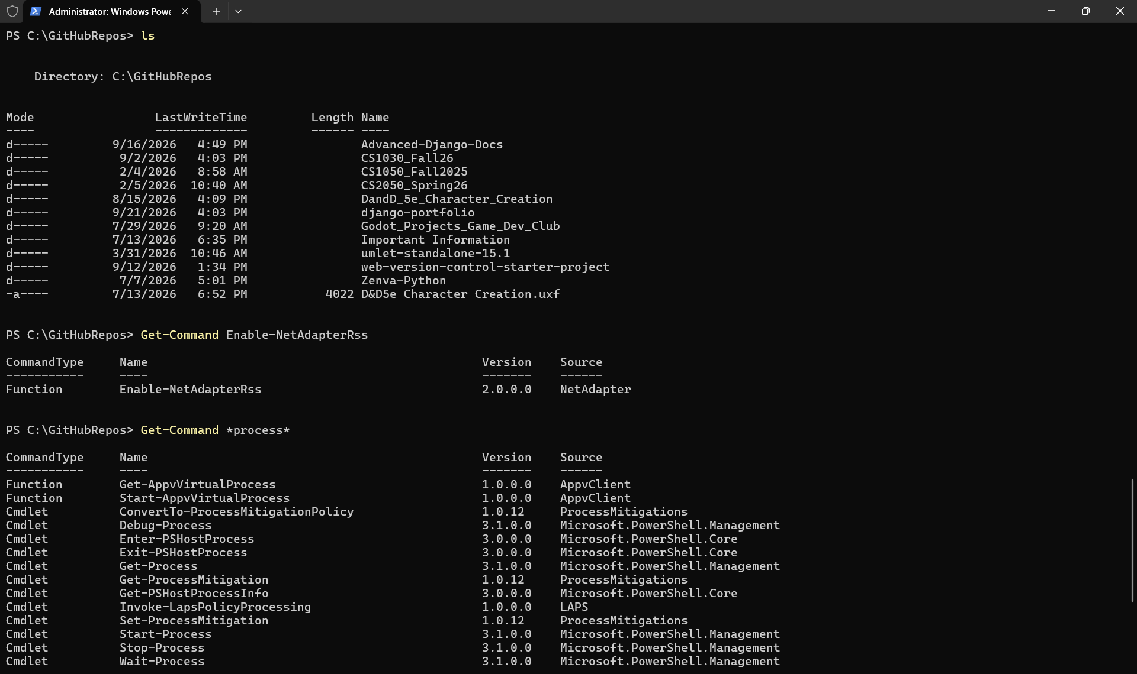

Unix Commands
There are many Unix commands but the main commands that we will use in this course are
Command | Command Name | Description
cd | Changed Directory(folder) | moves to a specified folder, can in the current folder, can move to folder above in the path using “cd ..”  Ex: cd .. – move to folder above current folder  cd c:\GitHubRepos\CS1030Fall26\Resources
touch | Create Blank File | Create a blank file, when creating you follow touch with the filename.filetype  Ex: touch index.html
ls | List Contents | Displays a list of all files and folders inside of a folder that are not hidden
mkdir | Make Directory | Create and name a folder in the current folder  Ex: mkdir Example_Folder
rm | remove | Deletes a file.  Warning: File will be deleted with no system check to make sure you are deleting the correct file. Only use when ABSOULTLY SURE that you are deleting the correct file. Permanently deletes a file items are not moved to recycle bin or trash can.
rmdir | Remove Directory | Deletes a folder  Warning: Folder will be deleted with no system check to make sure you are deleting the correct file. Only use when ABSOULTLY SURE that you are deleting the correct file. Permanently deletes a file items are not moved to recycle bin or trash can.
pwd | Display Directory Path | Displays the complete path for the current directory  EX. c:\GitHubRepos\CS1030\Resources
code(Windows) /open(mac) | Open in default programs (VSCode/VSCodium) | Opens a folder or file in the default program. In windows code is used instead of open. Will open current folder when followed by “.”  Ex: code . – Current folder  open index.html – opens index file
cp A B | Copy File | Copy a file from one folder to another folder
mv A B | Move File | Move file from one folder to another the folder. The folders paths must be listed when used.

Resources
Resource Name | Link
“Unix Commands Cheat Sheet: All the Commands You Need” | https://www.stationx.net/unix-commands-cheat-sheet/
“35+ PowerShell Commands You Must Know” | https://lazyadmin.nl/powershell/powershell-commands/
“Git – git Documentation” | https://git-scm.com/docs/git#_git_commands

